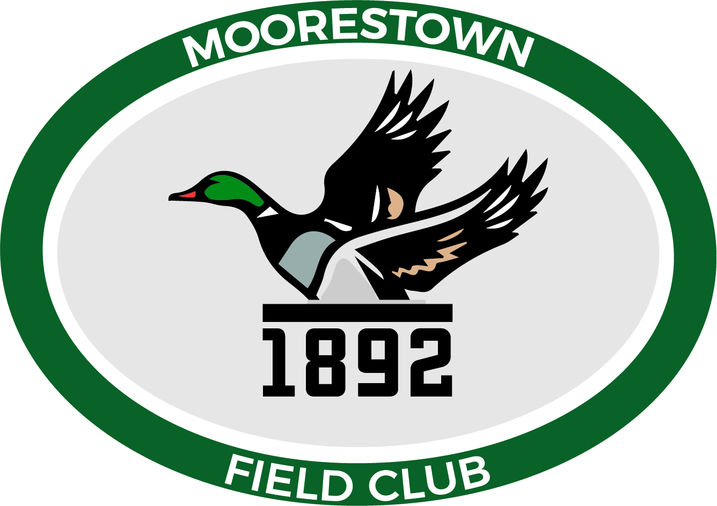
Moorestown Field Club
629 Chester Avenue Moorestown, NJ 08057
Phone 856-235-1464 Fax 856-234-8188
Email: office@moorestownfc.com

Minutes of Annual Membership Meeting on 02/24/2021

The Annual Membership meeting of the Moorestown Field Club was held on February 24, 2021 via a tele-video conference. A quorum of at least 10 members was reached and the meeting was called to order by President Matt Simeone @ 7:00 pm.

Board Members present: Matt Simeone, Stephanie Morrison, Dave Ricci, Jeff Beam, Brian Deam, Pat DeHart, Patrick Fowler, Jerry Miller, and Paul Gilhool. There were 51 additional members in attendance.

- Presentation: Various members of the Board and John Carpinelli provided:
  - a review of 2020 accomplishments and objectives for 2021
  - the Treasurer’s Report
  - the planned resumption of Food and Beverage Services and Food Minimum for 2021
  - the Capital Improvements completed in 2020 and planned for 2021
  - the Long Range Planning Committee’s process for developing an on-going 5 year plan

- Constitution and By-Laws Changes: The recommended changes to the current Constitution and By-Laws were presented and approved by the membership.
  - 50 Yes, 3 No, 7 Abstained

- Member Questions:
  - Q: How can access the Simulator when there are events in the clubhouse?
    - A: Access can be from the ProShop to the stairways or if the ProShop is closed, through the downstairs entrance.
  - Q: With the increase in members, are we able to repay all outstanding Bonds?
    - A: No. While we did make progress in redeeming bonds in 2020, there are still over 240 former members awaiting redemption. Note that since we allow new members to pay the bond over 3 years, one new member does not always equate to one bond redemption.
  - Q: Is there currently or are we considering a maximum number of members for the Club?
    - A: There is not currently nor are we intending to implement a waiting list.

The Meeting was adjourned at 8:00 pm.

